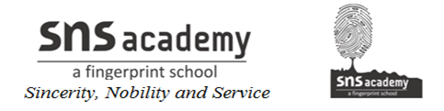

GRADE: IV NAME:
DATE: 18.11.20 SUB: SOCIAL
WORKSHEET -14
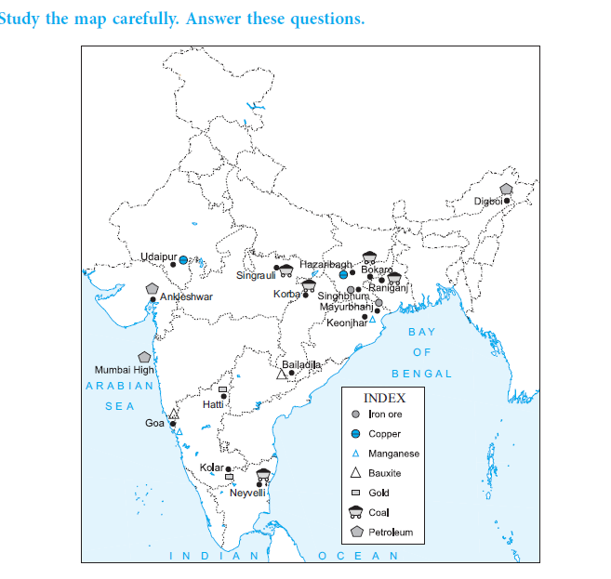
OUR MINERAL RESOURCES
